Full Stack Development with MERN Project Documentation

# Introduction

* + **Project Title:**

STREAMIFY: YOUR ULTIMATE OTT PLATFORM

* + **Team Members:**

**REPALLE RAJYALAKSHMI 218X1A0492**

**SHAIK SATHIRBASHA 218X1A04A3**

**SHAIK BASHEER 218X1A0496**

**SHAIK FAKRUDDIN 218X1A0497**

# Project Overview

**Purpose:**

The purpose behind creating the Streamify OTT platform revolves around the growing demand for seamless, personalized, and accessible entertainment.

## Features:

1. **Extensive Movie Collection:** Streamify offers a vast library of movies spanning across multiple genres, ensuring there's something for every viewer's taste. From action-packed blockbusters to indie gems and classic favourites, users have access to an extensive selection of high-quality content.
2. **Interactive Trailer Previews:** Enhance the user experience with interactive trailer previews for each movie
3. **Personalised Favourites:** Streamify allows users to personalise their movie-watching experience by saving their favourite movies to their account. With just a click, users can add movies to their favourites list, making it easy to revisit and watch them again at any time, creating a tailored and curated viewing experience.
4. **User-Friendly Interface:** The platform boasts a user-friendly interface designed for seamless navigation and optimal user experience. Intuitive search and browsing functionalities enable users to discover new movies effortlessly, while clean layout and clear categorization ensure easy access to desired content.

# Architectue

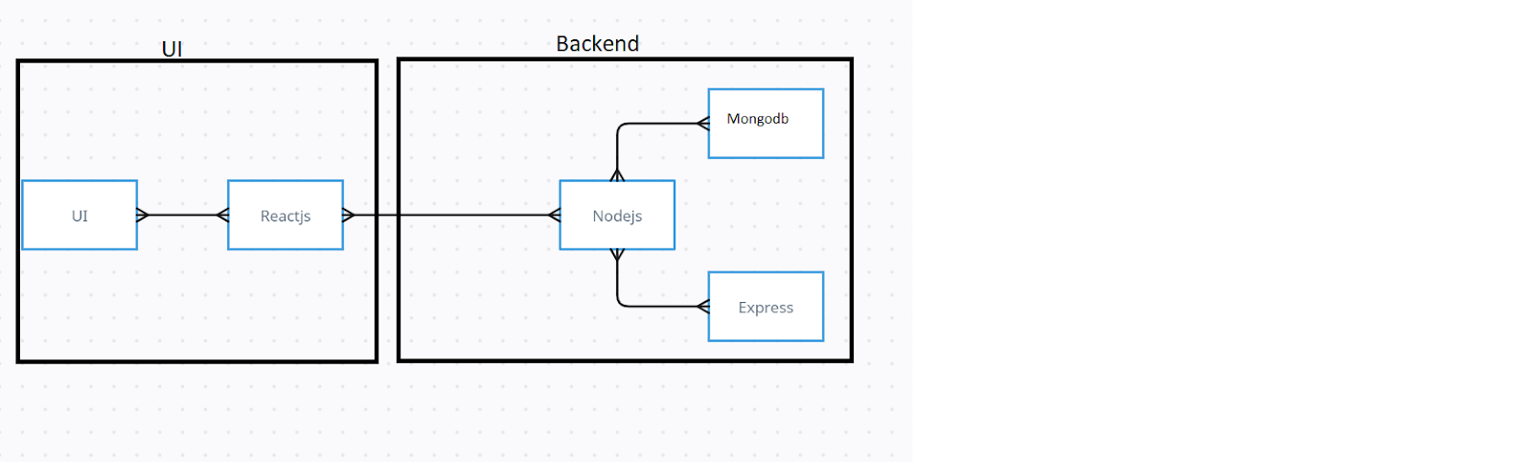

The technical architecture of Streamify OTT app follows a client-server model, where the frontend serves as the client and the backend acts as the server. The frontend encompasses not only the user interface and presentation but also incorporates the axios library to connect with backend easily by using RESTful Api.

On the backend side, we employ Express.js frameworks to handle the server-side logic and communication.

For data storage and retrieval, our backend relies on MongoDB. MongoDB allows for efficient and scalable storage of user data, adding docs etc. It ensures reliable and quick access to the necessary information.

Together, the frontend and backend components, along with Express.js, and MongoDB, form a comprehensive technical architecture for our streamify app. This architecture enables real-time communication, efficient data exchange, and seamless integration, ensuring a smooth and immersive OTT experience for all users.

1. **Setup Instructions:**

* **Prerequisities:**

Here are the key prerequisites for developing a full-stack application using Node.js, Express.js, MongoDB, React.js:

# Node.js and npm:

Node.js is a powerful JavaScript runtime environment that allows you to run JavaScript code on the server-side. It provides a scalable and efficient platform for building network applications.

Install Node.js and npm on your development machine, as they are required to run JavaScript on the server-side.

Download: https://nodejs.org/en/download/

Installation instructions: <https://nodejs.org/en/download/package-manager/>

# npm init

* **Express.js:**

Express.js is a fast and minimalist web application framework for Node.js. It simplifies the process of creating robust APIs and web applications, offering features like routing, middleware support, and modular architecture.

Install Express.js, a web application framework for Node.js, which handles server- side routing, middleware, and API development.

Installation: Open your command prompt or terminal and run the following command:

# npm install express

* **MongoDB:**

MongoDB is a flexible and scalable NoSQL database that stores data in a JSON-like format. It provides high performance, horizontal scalability, and seamless integration with Node.js, making it ideal for handling large amounts of structured and unstructured data.

Set up a MongoDB database to store your application's data. Download: https://[www.mongodb.com/try/download/community](http://www.mongodb.com/try/download/community)

Installation instructions: https://docs.mongodb.com/manual/installation/

# React.js:

React.js is a popular JavaScript library for building user interfaces. It enables developers to create interactive and reusable UI components, making it easier to build dynamic and responsive web applications.

Install React.js, a JavaScript library for building user interfaces.

Follow the installation guide: [https://reactjs.org/docs/create-a-new-react-](https://reactjs.org/docs/create-a-new-react-app.html) [app.html](https://reactjs.org/docs/create-a-new-react-app.html)

* **HTML, CSS, and JavaScript**:

Basic knowledge of HTML for creating the structure of your app, CSS for styling, and JavaScript for client-side interactivity is essential.

* **Database Connectivity**:

Use a MongoDB driver or an Object-Document Mapping (ODM) library like Mongoose to connect your Node.js server with the MongoDB database and perform CRUD (Create, Read, Update, Delete) operations. To Connect the Database with Node JS go through the below provided link: https://[www.section.io/engineering-education/nodejs-](http://www.section.io/engineering-education/nodejs-) mongoosejs-mongodb/

* **Front-end Framework**:

Utilize Reactjs to build the user-facing part of the application, including entering booking room, status of the booking, and user interfaces for the admin dashboard.For making better UI we have also used some libraries like material UI and boostrap.

* **Version Control**:

Use Git for version control, enabling collaboration and tracking changes throughout the development process. Platforms like GitHub or Bitbucket can host your repository.

Git: Download and installation instructions can be found at: https://git- scm.com/downloads

* **Development Environment**:

Choose a code editor or Integrated Development Environment (IDE) that suits your preferences, such as Visual Studio Code, Sublime Text, or WebStorm.

* Visual Studio Code: Download from <https://code.visualstudio.com/download>
* **Installation:**

**git clone**: https://github.com/[Sathirbasha12/streamify](https://github.com/RepalleRajyalakshmi/streamify)

Install Dependencies:

* Navigate into the cloned repository directory: cd project-streamify
* Install the required dependencies by running the following commands:

cd frontend

npm install cd ..

cd backend npm install

Start the Development Server:

* To start the development server, execute the following command: npm start
* The Content Management System for Blogs app will be accessible at <http://localhost:3000>
* You have successfully installed and set up the Content Management System for Streamify app on your local machine.

# Folder Structure:

## Client:

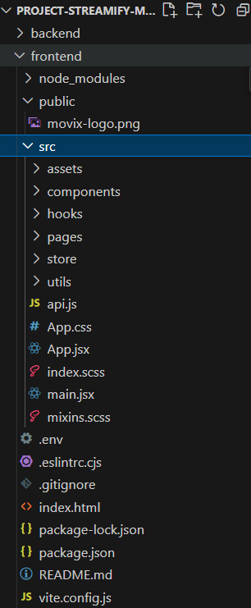

* The image is of frontend part which is showing all the files and folders that have been used in UI development.
* **Server:**

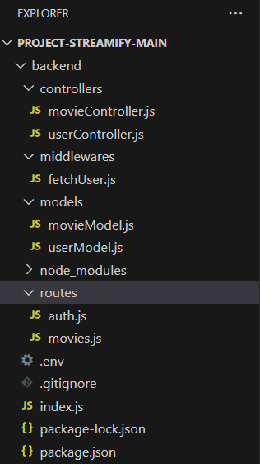

* + The image is of Backend part which is showing all the files and folders that have been used in backend development

# Running the Application:

* + Provide commands to start the frontend and backend servers locally.
    1. **Frontend:** npm run dev in the client directory.
    2. **Backend:** npm start in the server directory.

# API Documentation:

# Here's an API documentation outline for the Streamify platform backend, detailing common endpoints and their functionality. Each endpoint includes HTTP method, route, request parameters, example responses, and any relevant error codes.

# Authentication

## User Registration:

* + - When a new user signs up, their information (like username, email, and password) is sent to the backend.
    - The password is hashed using a library like bcrypt before being stored in the MongoDB database for security.

## User Login:

* + When a user attempts to log in, their credentials (email and password) are sent to the backend.
  + The backend checks the database for the user. If found, it verifies the password using

bcrypt.

* + If the credentials are valid, a JWT (JSON Web Token) is generated, containing user information (like user ID and roles) and is sent back to the client.

## Storing the Token:

* + - The client stores the JWT in local storage or cookies. This token is used to authenticate future requests to protected routes.

## Token Expiration:

* + JWTs typically have an expiration time. After expiration, the user must log in again to receive a new token.

## Middleware for Authentication:

* + - On the backend, middleware is used to protect routes. This middleware checks the validity of the JWT in incoming requests.
    - If the token is valid, the request proceeds; otherwise, a 401 Unauthorized response is sent.

# Authorization:

## Role-based Access Control:

* + - Users can have different roles (e.g., regular user, admin). This is defined when the user is created or modified.
    - When a user logs in, their role is included in the JWT.

## Route Protection:

* + - Protected routes (like creating or editing posts) check the user's role. For example, only admins may have access to user management features.
    - Middleware checks the user’s role before allowing access to certain routes.

## Frontend Authorization:

* + On the client side, the application can use the role information from the JWT to conditionally render components. For instance, only admins might see options to manage users.

## Handling Unauthorized Actions:

* + If a user attempts to access a resource they’re not authorized for, the backend responds with a 403 Forbidden status, and the frontend can display an appropriate message.
  + Details about tokens, sessions, or any other methods used:

# Tokens (JWT):

## What are JWTs?

* + - JWTs are a compact, URL-safe means of representing claims to be transferred between two parties. They are encoded as JSON objects and contain three parts: header, payload, and signature.

## How JWTs Work in This Project:

* + **User Authentication**: Upon successful login, the server generates a JWT that encodes user information (like user ID and roles) and is signed with a secret key.
  + **Structure**: A typical JWT looks like this: header.payload.signature.
    - **Header**: Contains metadata about the token, such as the signing algorithm (e.g., HMAC SHA256).
    - **Payload**: Contains the claims (user data) like sub (subject/user ID), role, and

exp (expiration time).

* + - **Signature**: Validates that the sender of the JWT is who it says it is and ensures that the message wasn’t changed along the way.

## Token Lifecycle:

* + - **Creation**: After a user logs in, the server creates a JWT and sends it back to the client.
    - **Storage**: The client typically stores the JWT in local storage or cookies.
    - **Authorization**: For subsequent requests, the client sends the JWT in the Authorization header, allowing the server to verify the user's identity and permissions.
    - **Expiration**: Tokens have an expiration time to limit their validity. After expiration, users need to log in again to obtain a new token.

## Benefits of Using JWTs:

* + - Stateless: No need for session storage on the server, reducing server load and making it easier to scale.
    - Cross-domain: Tokens can be sent via HTTP headers, making them suitable for APIs.

# Sessions

## What are Sessions?

* + - Sessions are stored on the server and maintained via session IDs. When a user logs in, the server creates a session and associates it with the user.

## How Sessions Could Work:

* + - **Session Creation**: Upon login, the server creates a session object and stores it in memory or a store like Redis. A unique session ID is generated and sent to the client.
    - **Client Storage**: The client stores the session ID in a cookie.
    - **Authorization**: For subsequent requests, the client sends the session ID cookie, allowing the server to retrieve the corresponding session data.
    - **Session Management**: Sessions can have a configurable expiration time, after which they become invalid.

## Benefits of Using Sessions:

* + - Simple to implement for small applications.
    - Easy to manage user state across requests.

# Choosing Between Tokens and Sessions

## Considerations:

* + - **Scalability**: For larger applications, JWTs are preferred due to their stateless nature, which avoids server-side session storage.
    - **Security**: Both methods can be secure if implemented correctly, but sessions require careful management of session storage and expiration.
    - **Use Cases**: If you need to support mobile apps or third-party integrations, JWTs might be more suitable due to their flexibility.

# User Interface

* Screenshots or GIFs showcasing different UI features:

**Register Page:**

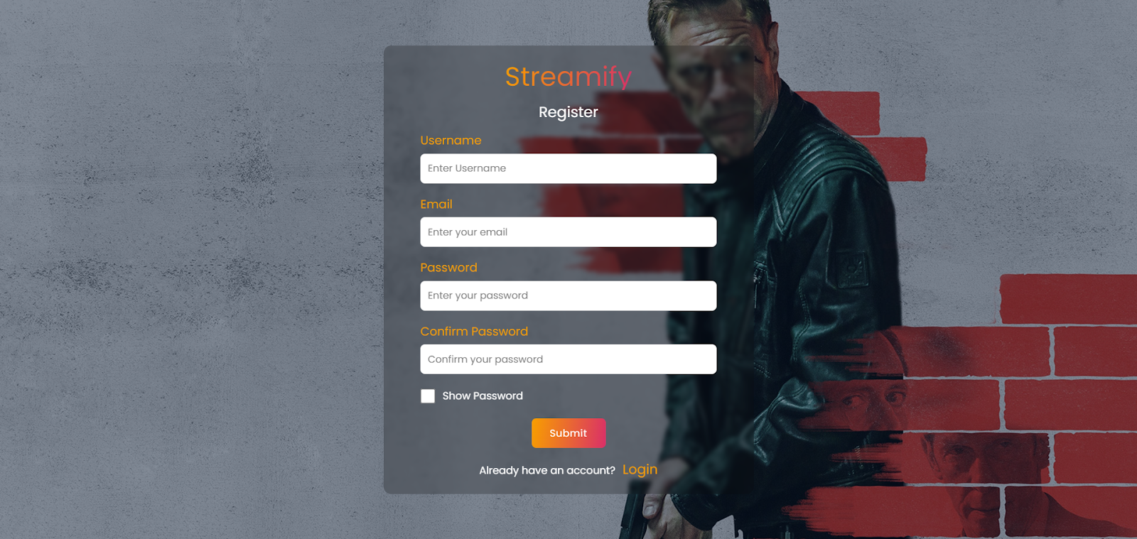

**Login Page**

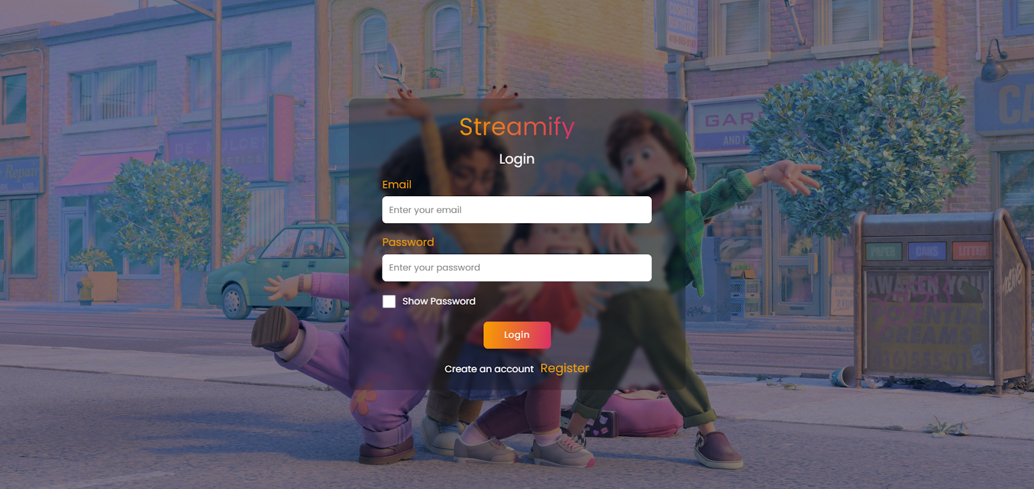

**Home Page**

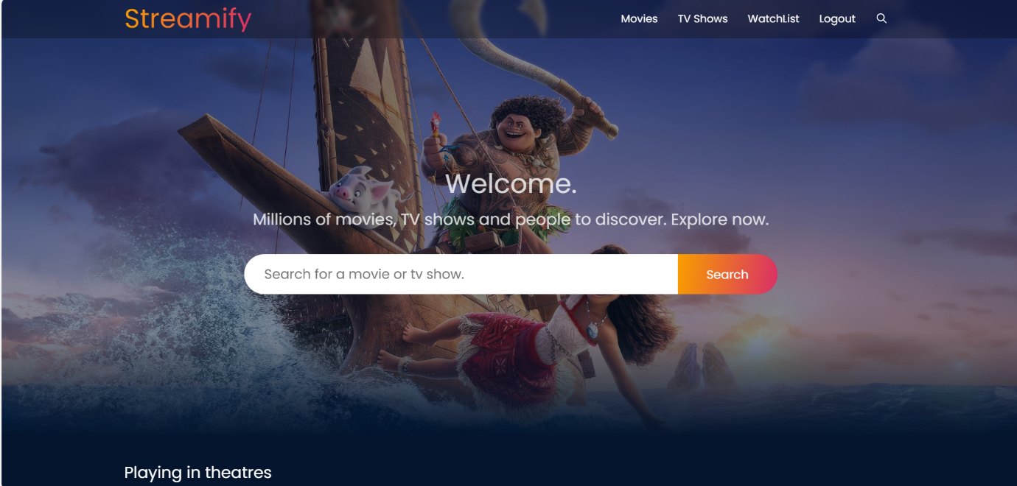

**Movies Page:**

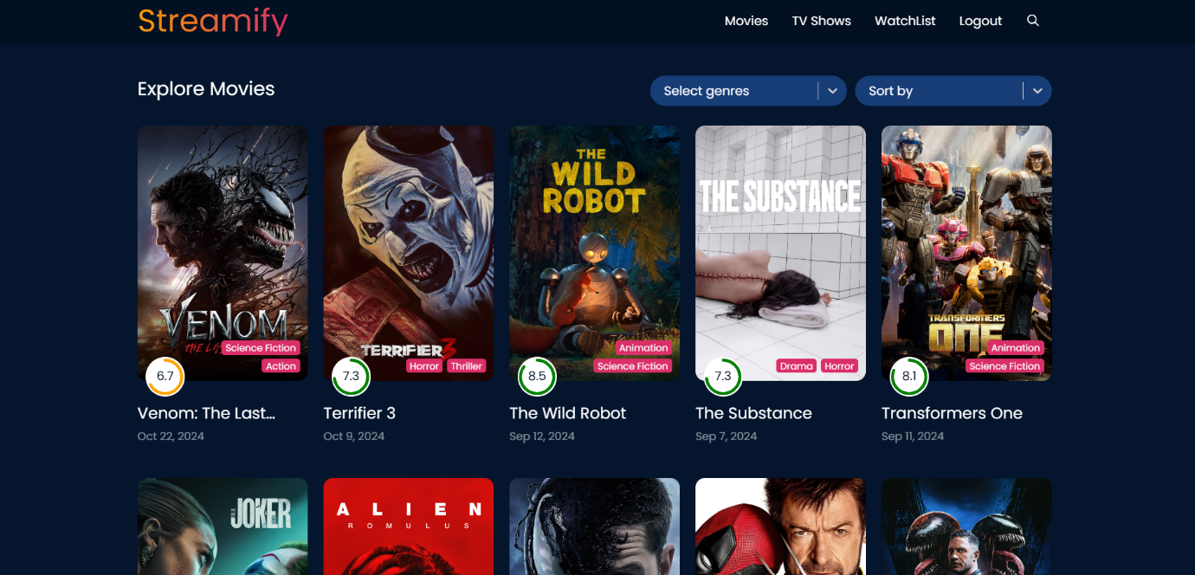

**TV Showes Page:**

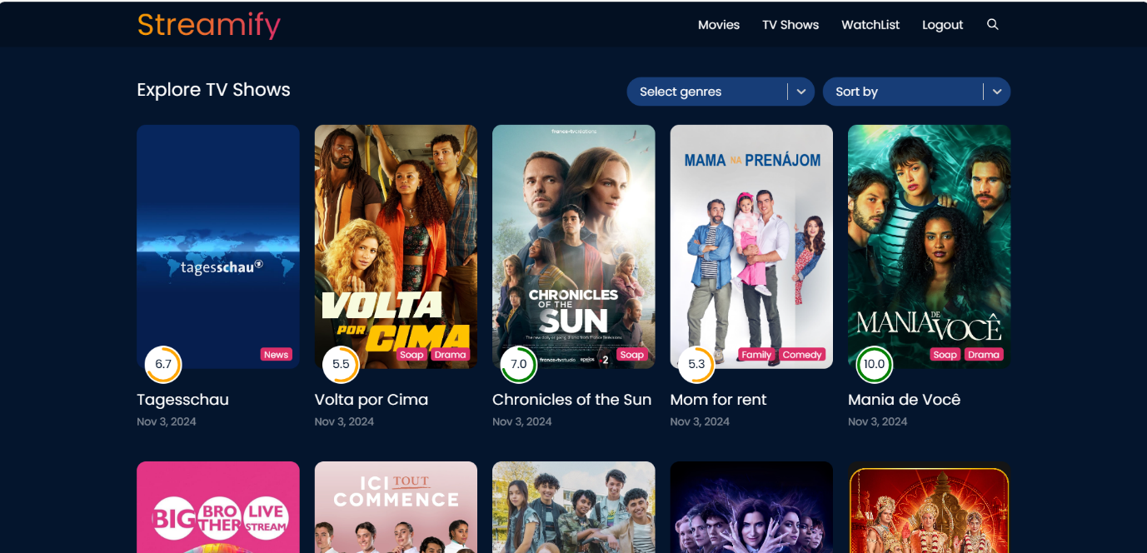

**Watch List Page:**

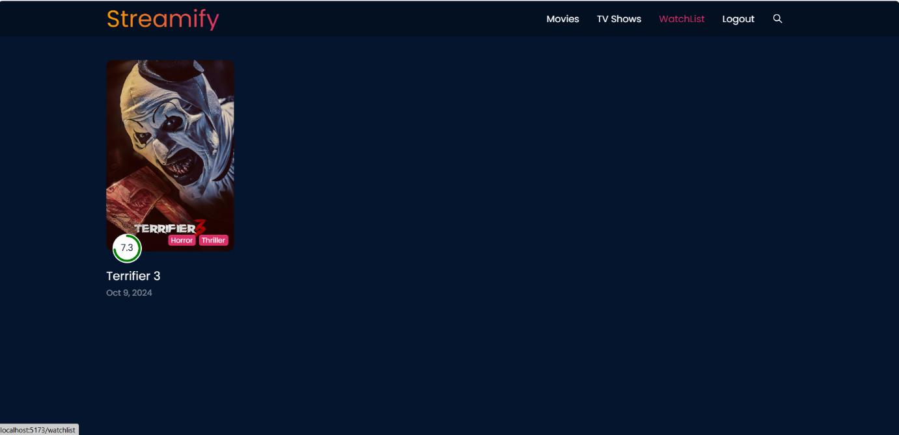

**Search Page:**



# Testing

# Testing Strategy

## Unit Testing:

* + **Objective**: Validate individual components and functions to ensure they behave as expected.
  + **Approach**: Write tests for critical business logic, utility functions, and isolated UI components.

## Tools:

* + - **Jest**: A popular testing framework for React that provides a simple API and great integration with other tools.
    - **React Testing Library**: For testing React components in a way that focuses on user interactions.

## Integration Testing:

* + **Objective**: Test how different components work together, especially for complex interactions and data flow.
  + **Approach**: Test interactions between components and verify that they integrate correctly with APIs and services.

## Tools:

* + - **Jest** (with React Testing Library): Can also be used for integration tests by simulating user interactions.
    - **Enzyme**: An alternative library for testing React components, useful for shallow rendering and full DOM rendering.

## End-to-End Testing

* **Objective**: Simulate real user scenarios to ensure the entire application functions correctly from the user’s perspective.
* **Approach**: Test critical user flows like creating a post, commenting, and navigating between pages.

# Screenshots or Demo:

* Demo Video Link:

<https://github.com/Sathirbasha12/streamify/blob/main/video%20demo%20link>

* Code Link:

https://github.com/[Sathirbasha12/streamify](https://github.com/RepalleRajyalakshmi/streamify)

# Known Issues

* Here are some potential issues that might be encountered:

# User Interface/Experience Issues:

* + - **Navigation Difficulties**: Users may find navigation between different sections (like the dashboard, posts, and settings) confusing.
    - **Mobile Responsiveness**: Some users might experience layout or functionality issues when accessing the platform on mobile devices.

# Performance Problems:

* + - **Slow Loading Times**: Posts with heavy media content may lead to longer loading times, affecting user engagement.
    - **Server Downtime**: Occasional outages or slow server responses can disrupt the user experience.

# Content Management Challenges:

* **Draft Recovery**: Users might face issues recovering unsaved drafts or auto-saves not functioning properly.
* **Version Control**: Lack of effective version control for posts can lead to confusion, especially in multi-author environments.

# Search and Discovery Limitations:

* + - **Ineffective Search Functionality**: Users may struggle to find specific posts or topics due to inadequate search filters or algorithms.
    - **Limited Tagging and Categorization**: A poor tagging system may hinder content discovery and organization.

# Commenting and Community Engagement Issues:

* + - **Spam and Moderation**: Users may report spam comments and a lack of effective moderation tools.
    - **Notification Delays**: Notifications for comments or interactions might be slow or inconsistent, affecting community engagement.

# Integration Problems:

* + - **Third-Party Tool Compatibility**: Users may encounter difficulties integrating with other tools

# Future Enhancements:

Future developments in OTT apps could include: deeper AI-powered personalization, immersive experiences with AR/VR integration, interactive content, social viewing features, enhanced live streaming capabilities, improved content discovery with advanced search and filtering, seamless multi-device syncing, and integration with emerging technologies like 5G for better streaming quality; all while prioritizing user privacy and data security.

**Advanced AI-driven personalization:**

Highly curated recommendations based on user behavior, mood, and context.

**Social viewing features:**

Live chat and discussion forums during content playback

**Enhanced live streaming capabilities:**

High-quality live events with low latency

**Immersive experiences with AR/VR:**

360-degree video content for virtual reality viewing